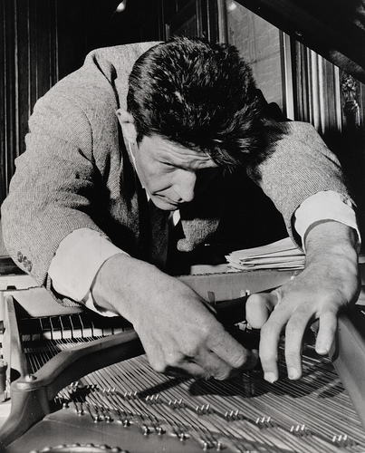

John Cage “preparing” the piano- using small objects to
insert between the strings of the piano to create a
completely different tonal quality

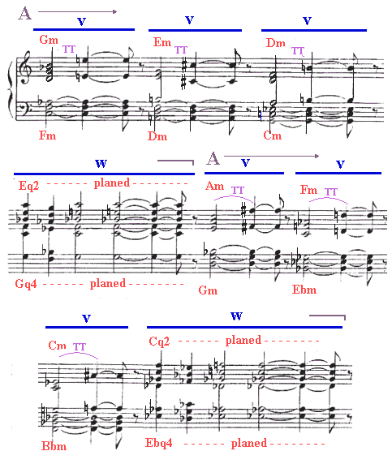

Polychords

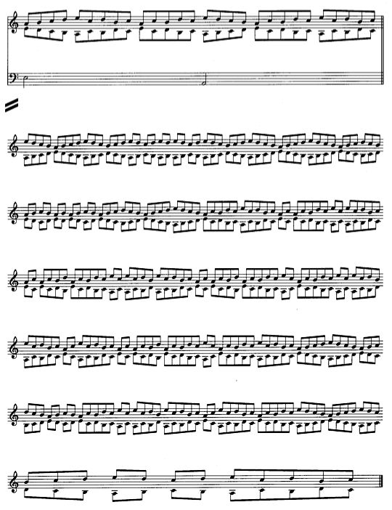

Serialism- repeated patterns of music over time created through mathematics and the computer to create a hypnotic, controlled form of music
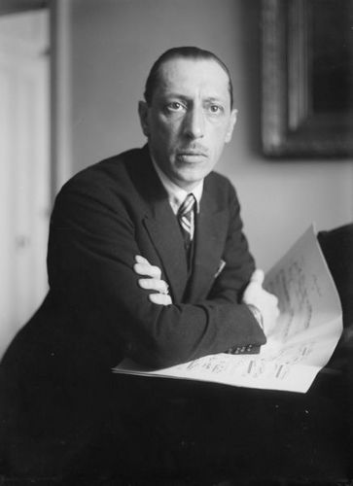

Igor Stravinsky fled to America, bringing music from both Russia and France. He was forced to leave his countries because of social and political movements, and this sentiment and cultural history is reflected through the music that he composed.

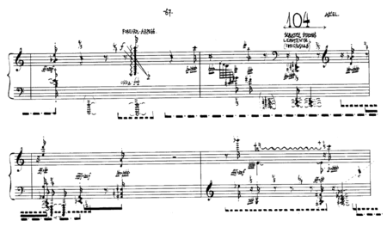
A piece of aleatoric sheet music- instructions given in the music for duration of different chord and note patterns to be played at free will of the performer

